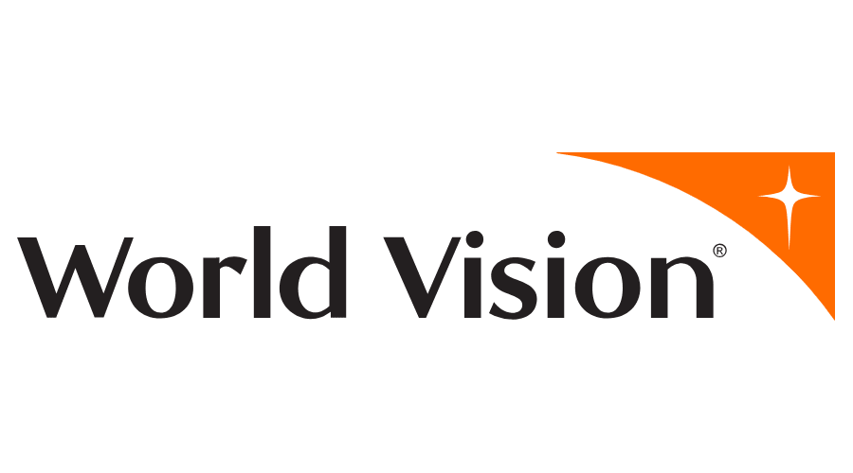

**Dated: 02/02/2024**

**Point of Contact**

**Mohan Krishna**

**mohan.p@changepond.com**

Changepond Response to wORLD VISION UK FOR WEBSITE PLATFORM MIGRATION, SUPPORT, MAINTENANCE & DEVELOPMENT

Table of Contents

1 Executive Summary 4

2 Company Background 4

2.1 About Changepond 4

2.2 Our Journey 5

2.3 Facts & Figures 5

2.4 Clients 6

2.5 Our Service Portfolio 6

2.6 Culture Alignment 7

2.7 Agile Methodology 7

2.8 Our Working Model with World Vision 8

2.8.1 Donor Management strategy 8

2.9 Concept to Reality 9

3 Our Association with World Vision 9

4 Understanding of World Vision 10

5 Our Solution Approach 10

5.1 Phase 1 – Platform Migration 10

5.1.1 Objective 10

5.1.2 Removal of Non-UK specific code 10

5.1.3 Umbraco Upgrade 11

5.1.4 Conclusion 11

5.2 Phase -2 Ongoing Support and Maintenance 11

5.2.1 Objective 11

5.2.2 CMS 11

5.2.3 Data 11

5.2.4 Functionality 12

5.2.5 Hosting and Platform Enhancement 12

5.2.6 Management 12

5.2.7 Platform, Scoping, Security 12

5.2.8 SEO & Analytics 13

5.2.9 Sandbox Environment 13

5.2.10 User Management 14

5.3 Phase 3 – Development & Optimization 14

5.3.1 Objective 14

5.3.2 Development 14

5.3.3 Optimization 14

5.3.4 Summary of Execution model 15

6 Why Changepond? 15

7 Team Structure 17

8 Phase 1-Estimation 17

9 Pricing and Estimation 18

10 Relevant Experience and Case Studies 18

# Executive Summary

We are thankful for the opportunity to present our proposal to be World Vision UK's Digital media partner leveraging the United 4 platform. Our plan comprises integrating the Supporter Office – United 4 Admin tool, implementing DevOps for streamlined processes, and maintaining a robust digital infrastructure.

The proposed solution unfolds in three strategic phases: optimizing system performance through seamless Umbraco migration and code refinement, ensuring robust ongoing support and maintenance services with a proactive approach, and collaborating with World Vision to implement enhancements and optimize performance iteratively.

This holistic approach aims to provide a seamless, efficient, and continually improving digital platform aligned with World Vision UK's goals and expectations.

World Vision UK can garner the benefit of our digital capabilities and unwavering commitment to measurable improvement of their business objectives, brand and donors base. Changepond is uniquely positioned to provide significant benefits via our:

* 24 years of experience in IT Services
* Changepond is a pioneer in agile practices, having adopted it since 2009 as one of our core delivery approaches.
* Proven track record in bringing out agility and supporting marketing operations
* Experience in developing and managing 100+ CMS based websites
* New Media DNA blending web technology, data, digital marketing, and creative capabilities
* Better understanding on World Vision UK process, governance, system and technology landscape.

# Company Background

## About Changepond

Changepond is a global technology consulting and software services company with 24 years of experience, headquartered in Chennai.

We enable and fast-track our customers’ business into the digital era by improving your operational efficiency, envisioning and building remarkable customer experiences, and innovative new business avenues.

We specialize in transformation solutions that cover Hyper Automation solutions & services, Cloud Architecture & Technology services, and Performance Engineering & Automated Testing services. We deliver best-in-class digital solutions for our customers using Design Thinking methodology, powered by Agile-based SAFe, DevOps practices, and leveraging technology partnerships with market-leading platform providers.

## Our Journey

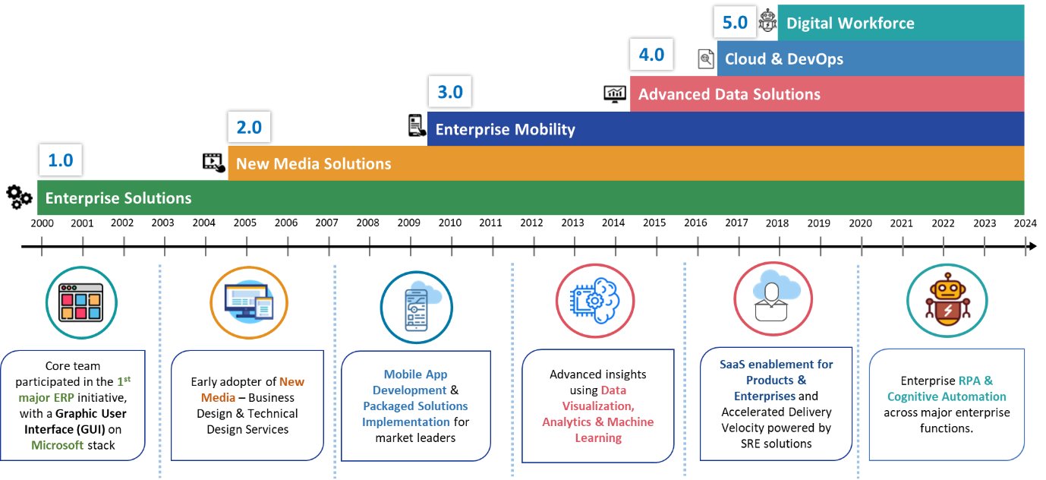

## Facts & Figures

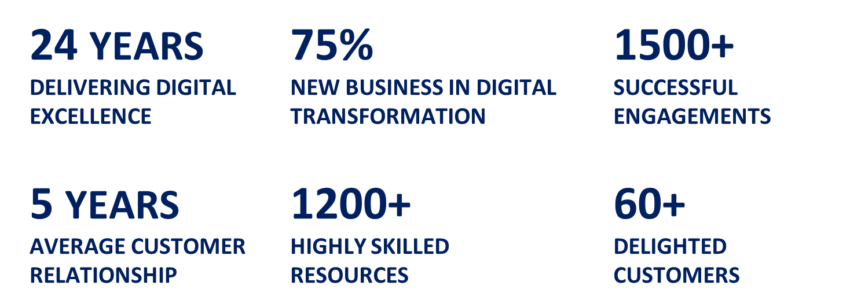

## Clients

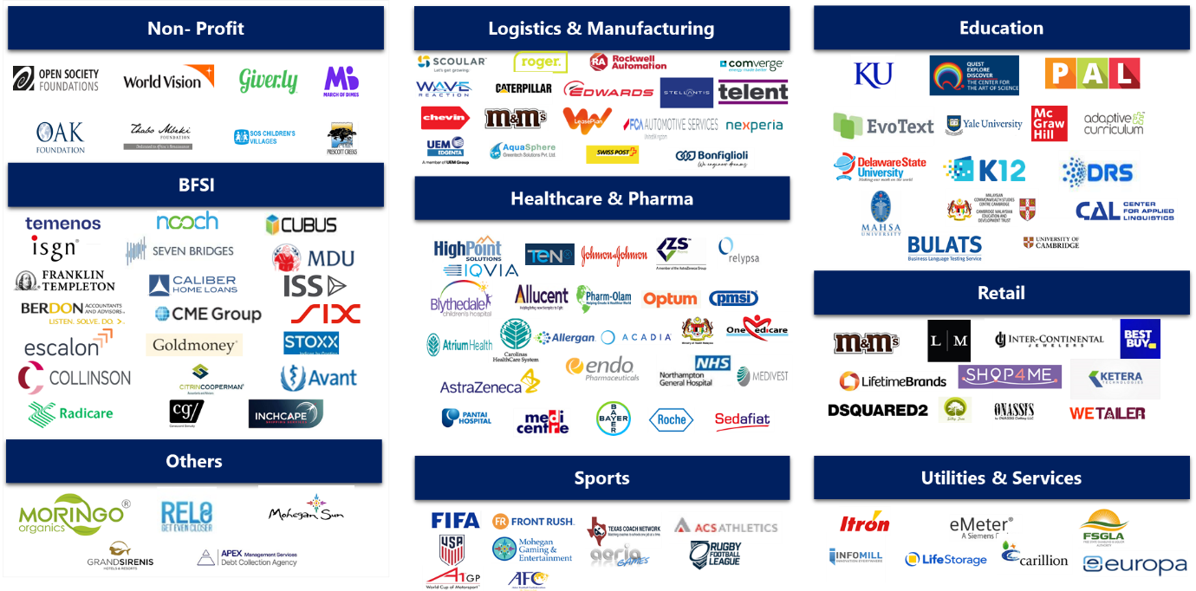

## Our Service Portfolio

Our service portfolio includes application development, testing, deployment, and maintenance aimed to help clients drive business agility through transformation and cost efficiencies. We specialize in enterprise solutions, cloud enablement, digital transformation, mobility, business intelligence and Data analytics, independent testing and managed infrastructure services

The new technology areas and specific initiative details are provided below:

* **Digital Customer Experience -** Changepond offers digital optimization and approaches for Enterprises to transform legacy monolithic applications into Micro-services.
* I**ntelligent Automation -** Changepond’s Intelligent Automation solutions deliver a unified, open, and dynamic suite of automation tools, services and expertise that serves your business as a continuously evolving source of innovation and value.
* **Digital Assurance** - Changepond’s solution-led digital assurance practice enables this critical quality assurance to digital assurance transition through a consultative solution-led approach.
* **Cloud Services** - Changepond’s Cloud-First strategy offers a full spectrum of cloud services to help you realize the value of your investment. Changepond can help you embrace change and realize value faster, regardless of where your enterprise is in its cloud journey.

## Culture Alignment

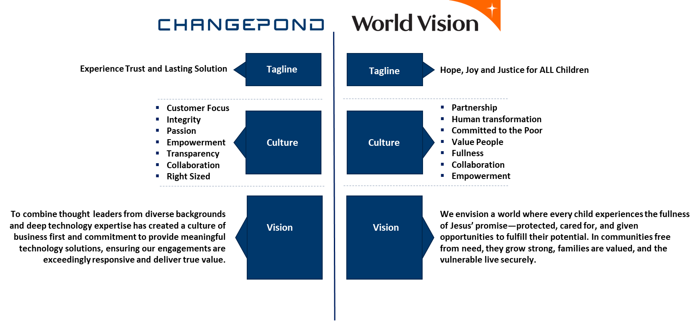

## Agile Methodology

**Agile @ Changepond:**

From 2009, Changepond’s agile delivery model has kept in mind the key objective which is to deliver faster delivery of solutions to businesses which is focused on Innovation, benefits, and productivity through IT

**Visible Advantages for the customer through this approach are**

* Collaborative work environment that provides highest visibility for priorities, milestones and tasks
* Quality of development and solution delivery is seen as a “Top Priority”
* Collaborative and Proactive Risk Management

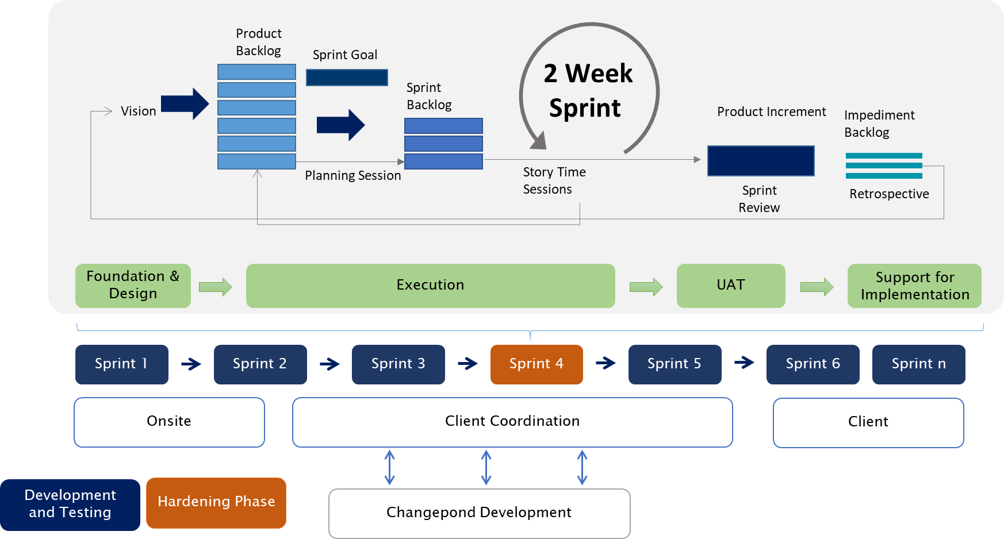

## Our Working Model with World Vision

The goal of the World Vision UK is to use the platform to provide insights into how we can significantly contribute to the development of your website that not only ensures seamless customer engagements, but also allows for comprehensive tracking of the user journey from initial interaction to conversion.

Our approach to website development focuses on creating a user-centric experience, with particular emphasis on understanding and improving the user journey. Here's how we achieve this:

* Seamless Customer Engagement
* Tracking User Journey
* Measuring drop rate through funnel creation
* Proactive issue resolution
* Continuous Improvement

We are enthusiastic about the prospect of collaborating with your team to enhance your marketing strategy.

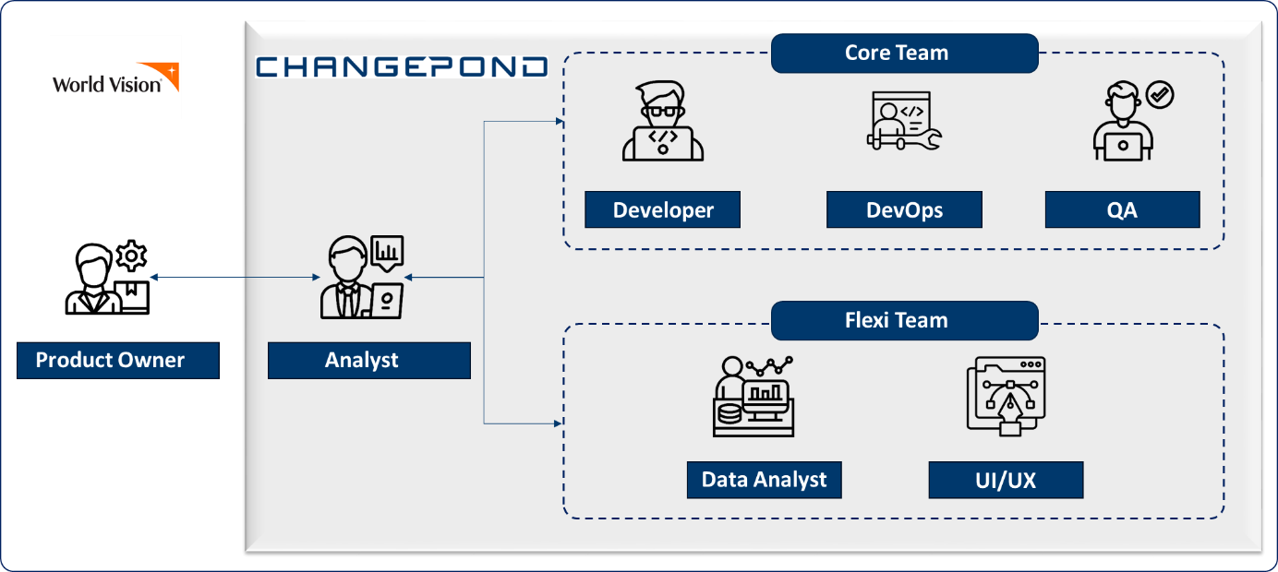

### Donor Management strategy

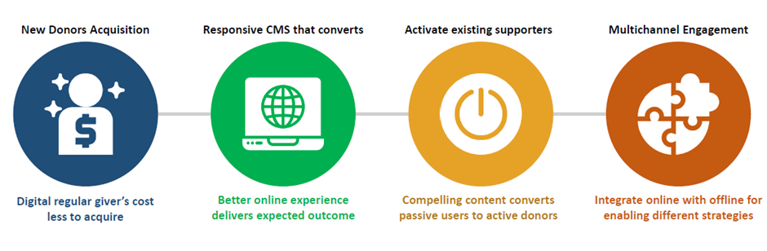

## Concept to Reality

We believe that for any platform - Concept and ideation are the base. We adhere to the following model

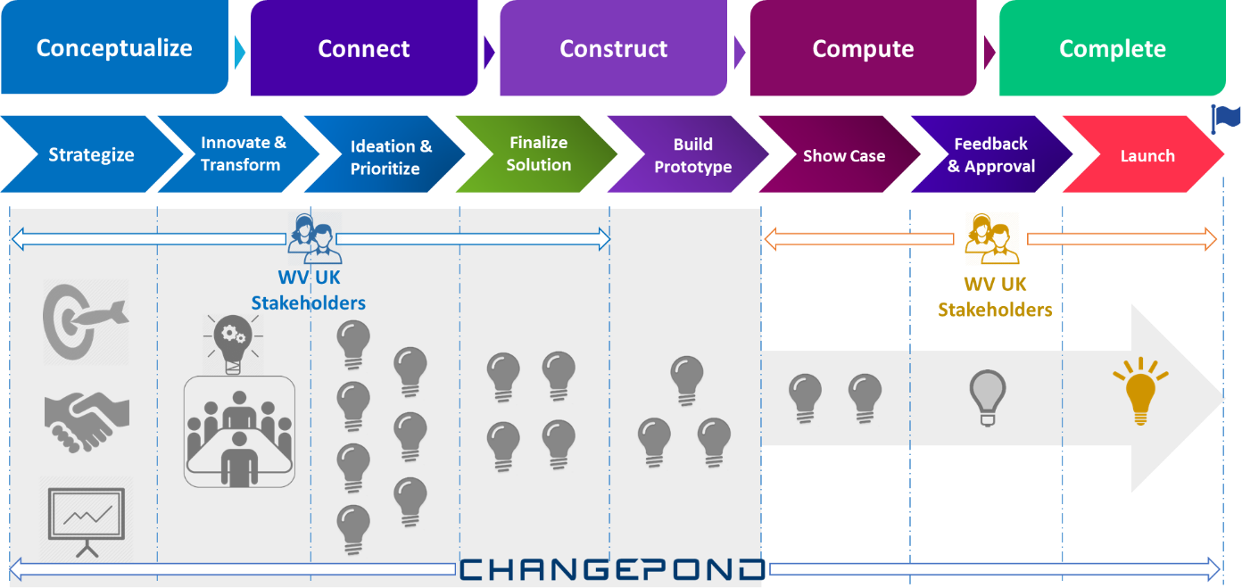

# Our Association with World Vision

Changepond has been World Vision's strategic partner throughout a successful enterprise-wide business transformation, digital and analytics engagements. The engagement kicked off in 2019 with various activities, assessments and the initiation of strategic planning. We crafted a robust architecture for the United Platforms, implemented DevOps practices and integrated security throughout the life cycle. In 2020, we adopted cloud solutions to enhance scalability and efficiency.

In 2023, Changepond managed subscription services, migrated identity management and also streamlined the automated testing process. Integrated Customer Relationship Management tools and deployed a custom API gateway. Ongoing refinement and enhancement of system resources were prioritized for continual optimization

**Key highlights of our engagements include:**

* Extension of the offshore IT arm of World Vision in Chennai.
* End-to-end responsibility for the United 4 Platform from inception to delivery.
* Building deep techno-functional experience.
* Implementation of a scalable framework with a Center of Excellence in place.
* Proven governance with engagement metrics.
* Development of a highly scalable Cloud Native Architecture and design.

# Understanding of World Vision

**Appreciation:**

World Vision is a Global Humanitarian organization that has been making significant contributions to alleviate poverty and improve the lives of children and communities around the world. We appreciate World Vision's commitment to addressing the root causes of poverty and its holistic approach that includes education, healthcare, economic development and community empowerment.

The Organization's focus on child well-being and protection reflects a deep understanding of the interconnected issues that impact communities. World Vision's dedication to sustainable development and disaster response demonstrates a proactive and adaptive approach to the evolving needs of the communities it serves.

The organization's work is characterized by a strong sense of empathy, cultural sensitivity and a commitment to the principles of social justice.

**Understanding:**

Our team understands the essence of World Vision and seeks to elevate its impact through technological solutions that attract and engage more donors. We are confident of supporting World Vision UK's digital presence to deliver effective communication, leveraging advanced analytics for donor insights, developing mobile-friendly solutions, creating interactive multimedia content, and implementing Donor Relationship Management systems. These initiatives aim to not only increase donor numbers but also foster long-term relationships by showcasing impact and authentically engaging supporters.

# Our Solution Approach

Presently, the WVI team, in collaboration with Changepond, is actively engaged in a series of initiatives aimed at facilitating an upgrade. This involves eliminating redundancy at the Content Management layer and optimizing backend Microservices. Careful planning has gone into scheduling these tasks over the next few months, laying the groundwork for Phase 1. We recommend allowing sufficient time for these tasks to evolve, ensuring a smooth transition for the technology upgrade that aligns with Umbraco support and enhances application scalability in the long run.

## Phase 1 – Platform Migration

### Objective

To optimize system performance and enhance scalability by successfully migrating the existing platform to a latest stable Umbraco version, ensuring minimal disruption to users. Umbraco version that has long term support will be prioritized.

### Removal of Non-UK specific code

* Analyse and then document the Non-UK specific functionalities and Micro services
* Prepare a plan and remove the documented functionalities
* Test and ensure no negative impact to the existing features
* Update the unit test cases and regression automation test scripts
* Update the DB installation scripts
* All of the above mentioned in this section will be flagged off in agreement with **WVUK Product Owner**

### Umbraco Upgrade

* Umbraco 13 which holds the long term support (Dec 14, 2026) is suggested as the target version. Added advantage is that it supports .NET 8 (Latest version).
* The path for upgrading Umbraco from 8 to 13, will be two stages.
  + Initial stage will be 8 to 10 migration which includes code change from .NET framework to .NET core
  + The final stage is 10 to 13 migration ­­which might have minimal code changes
* Analyse and identify the compatible plugin versions.
* Update the identified compatible plugins.
* Test and resolve any other compatibility issues.
* Perform rigorous testing to ensure the upgraded website functions seamlessly
* Build the YAML pipeline for the non-live environment and regression test
* Spin up the sandbox environment for testing the upgraded Umbraco code base.

### Conclusion

**Maintaining a consistent appearance and enhanced user experience will be upheld throughout this phase.**

The look and feel will not be changed during this phase.

## Phase -2 Ongoing Support and Maintenance

### Objective

Our support and maintenance is designed to provide comprehensive coverage for your system, ensuring security, maximum uptime and a proactive approach to bug fixes, platform upgrades and ad-hoc support.

### CMS

* CMS and Plug-ins with the latest stable version will be handled
* CMS standards will be followed while creating new document types, pages, or any such elements in the back office
* Dedicated support channels for any CMS-related queries will be allocated.

### Data

* Periodic check on the United 4 admin functionalities
* Continuous enhancements on data exports and child upload features
* Test run on APIs of corresponding Micro services to capture any defects and bugs.

### Functionality

* Identifying bugs, throughout the site and providing corresponding fixes at different levels as required. Which includes changes at CMS (Back office), Micro service and Umbraco code.

### Hosting and Platform Enhancement

* We can collaborate with Phoenix to receive updates and understand other impacts to the platform
* Analyse hosting solutions for scalability, security and performance
* Migrate to a more robust hosting environment for better reliability
* Optimize the platform architecture to support increased traffic and functionalities

### Management

* Our team is equipped with proficient marketing data analysts who can swiftly measure and interpret the data related to user conversions and drop rates
* Ensures that our Marketing team can swiftly respond to identified issues and implement changes or new modules in an accelerated timeframe.
* Leveraging our expertise, we can swiftly develop and deploy targeted modules or applications aimed at resolving specific issues affecting user conversion rates or causing drop-offs.
* By understanding user behaviour and preferences, we can craft solutions that not only address technical issues but also enhance the overall user experience.
* Provide iterative approach to development and improvement.
* Regular monitoring and analysis ensure that we stay proactive in identifying emerging issues and continuously refining our solutions for optimal performance.
* Triaging will be handled by the Business Analyst
* We operate within overlapping time zones, with availability spanning from **(06:00 – 15:00 UTC) Mon-Fri. Excluding Indian holidays**
* We extend our support for any business critical issues, when the site is down or whole-site payment failure.
* Page Performance, site performance and code quality will be monitored with respective Demos as expected. Improving areas will also be recommended
* Our representative will provide inputs and suggestions on the new CRM integrations.

### Platform, Scoping, Security

* Umbraco CMS best practices will be captured and followed
* Define the scope of bugs raised and triage as per the severity
* Security measures and remedies will be planned and implemented.

### SEO & Analytics

* Leveraging advanced analytics tools, we can help World Vision gain profound insights into donor behaviours, preferences, and motivations.
* This data-driven approach enables personalized engagement strategies tailored to resonate with specific donor segments.
* Implement robust analytics tools to track user interactions from the moment they land on the website to the point of conversion.
* Granular data is collected to understand user behaviour, preferences, and pain points throughout their journey.
* A comprehensive funnel is created to map out the user journey, identifying key touchpoints and potential areas of drop-off.
* We utilize analytics to measure drop rates at each stage of the funnel, providing actionable insights into user behaviour and preferences.
* By analysing the funnel, we gain valuable insights into where users are dropping off and the reasons behind it.
* This understanding allows us to identify pain points, optimize user pathways, and improve overall website performance.
* Armed with data-driven insights, we proactively address areas that require user attention, eliminating bottlenecks and friction points.
* Conducting thorough keyword research to identify relevant terms and phrases that potential donors are likely to search for.
* Crafting compelling and informative content that resonates with both donors and search engines.
* Implementing technical SEO optimizations, such as improving website loading speed, optimizing Meta tags, and enhancing mobile responsiveness.
* Employing schema mark-up to provide search engines with clearer information about World Vision's content, enhancing the likelihood of appearing in featured snippets and rich search results.
* Data Layer and Tracking code modification as per requirement
* Handling Redirect via plugin as per the request
* Implement and Maintain tracking code in the Umbraco repo

### Sandbox Environment

* Sandbox will be the Development environment, where they run their initial level of testing- Since random content might be created by the Developers. Periodic latest DB updates will be performed
* Log clean-up activity will be set up by DevOps.

### User Management

* Support will be extended for Umbraco-level users, user permission creation and modifications

## Phase 3 – Development & Optimization

### Objective

To collaborate with World Vision in implementing a fast followers backlog of enhancements and an ongoing optimization program, with the primary goal of iteratively improving the performance of the website.

### Development

* Implement the planned enhancement and upgrades based on defined scopes
* Utilize an iterative development approach to incorporate continuous improvement
* Suggestions will be provided for user-friendly optimized websites
* New features will be developed with industrial best practices and ensure cross-browser compatibility and responsiveness

### Optimization

* Align content with World Vision's core values and mission, fostering an emotional connection with users by showcasing real-life impact stories and the organization's global outreach.
* Regularly analyze analytics data to identify user behavior trends and optimize campaign pages accordingly, ensuring that content and design resonate effectively with the target audience.
* Conduct A/B testing on different elements of campaign pages, including headlines, visuals, donation call-to-actions, and storytelling formats and Use insights from A/B testing to refine and enhance elements that drive user engagement and conversion, creating a user experience tailored to maximize donor contributions.
* Leverage user data and segmentation to deliver personalized content that resonates with specific user profiles.
* Implement dynamic content strategies, tailoring messaging based on users' previous interactions, preferences, and engagement history, enhancing the likelihood of converting users into committed donors.
* Set up behavioural triggers that initiate automated campaigns based on user actions, such as incomplete donation attempts or repeated visits to specific impact stories.
* Build campaign pages are designed for optimal user experience, with intuitive navigation and clear calls-to-action guiding users toward the donation process.
* Monitor user feedback and behaviour to make design adjustments that enhance usability and minimize friction points in the donation journey.
* Continuously monitor website performance for bottlenecks and optimization opportunities
* Optimize loading times, streamline processes and improve functionalities
* Understanding the Supporter’s interaction using external tools like - GTM, HotJar etc. will help us enhancing the product effectively.

### Summary of Execution model

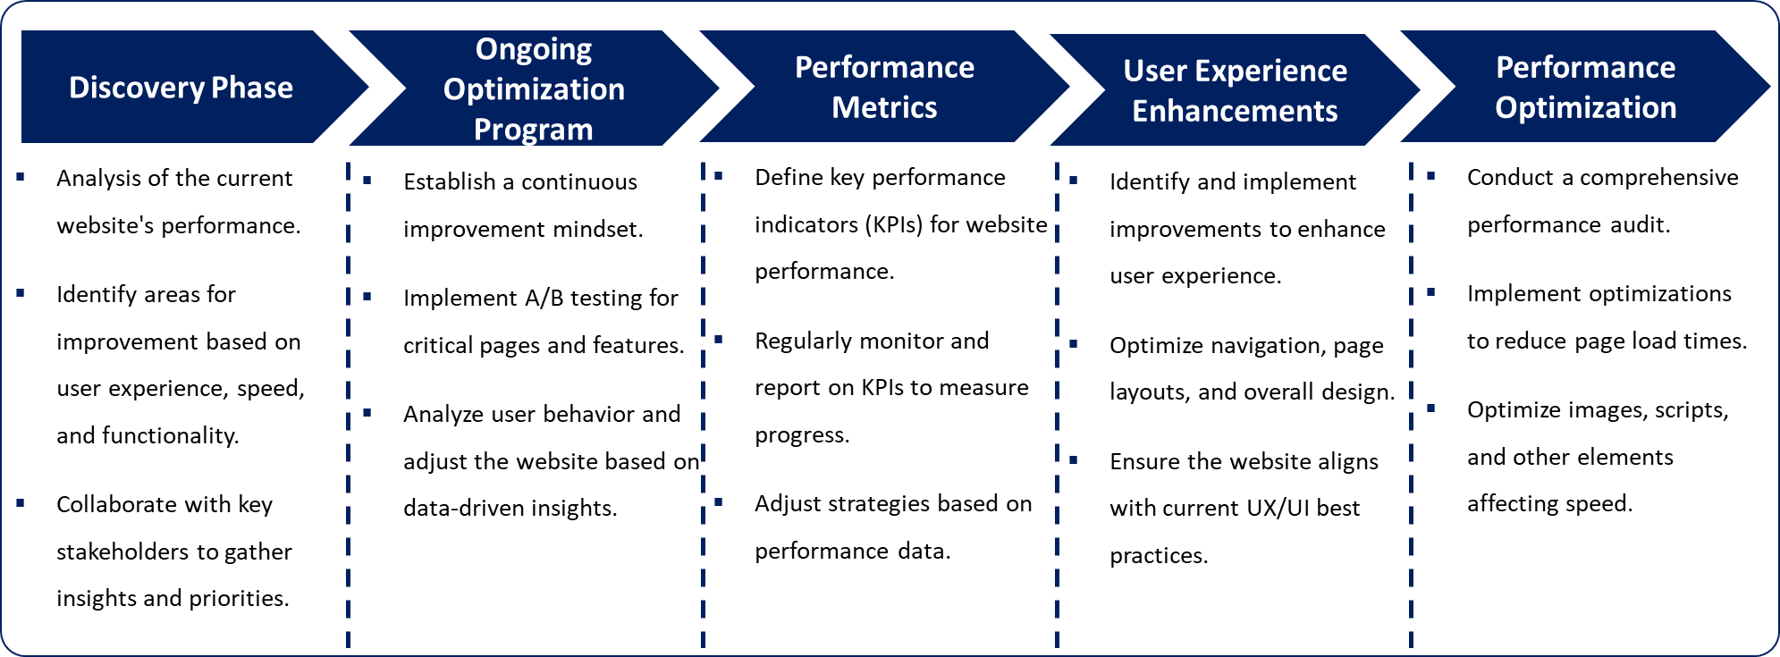

# Why Changepond?

Our organization goes beyond mere observation; we conduct thorough analyses of business needs aligned with supporter expectations. This ensures the smooth fulfilment of requirements. Leveraging our unique insights and expertise, we not only meet expectations but also optimize the process, transforming what might appear as a daunting task into a seamless experience. In doing so, we provide unparalleled value addition.

Effectively handling Umbraco Back Office content, applying DevOps strategies, supervising environment creation and maintenance, and integrating automation all require tackling a variety of challenges. These challenges highlight the need for a diverse team, as illustrated by different streams below

**Marketing:**

We bring over two decades of New Media DNA, crafted in blending web technology, data, digital marketing, and creative storytelling to achieve real-world marketing outcomes. We expertise lies in:

* Understanding unique marketing goals and challenges.
* Leveraging technology to build engaging and effective online experiences.
* Crafting compelling creative that resonates with target audience.
* Boost brand awareness with viral campaigns and influencer partnerships.
* Capture leads through personalized experiences.
* Optimize campaigns for maximum ROI through constant A/B testing and analytics.
* Craft narratives that resonate with your audience, driving action and donations.
* We specialize in creating engaging content and help you develop impactful campaigns.
* **Search Engine Optimization (SEO):** Optimize the website for search engines to ensure it appears prominently when people search for related keywords. This can increase organic traffic and visibility.

**Development Team:**

* Our Team has implemented most of the Umbraco features, which eventually makes it simpler for us to make modifications and suggest better options.
* We have always followed the best practices in building the Umbraco back-office elements, which makes the job simpler for Editors.

**DevOps Practices:**

* Our Changepond DevOps engineers are already aware of process to create the Azure resource.
* We have managed the migration from World Vision UK to WVI, so we are uniquely positioned while moving back to World Vision UK. Added to which we have the processed documentation and checklist handy.
* We have great exposure and experience spinning up the environment which saves time.
* We have made multiple recommendations such as switching to different services and resources. Where the primary focus was cost optimization.
* We are aware of the branching strategies and release activities flow, we can follow the same existing strategies for the World Vision UK.
* Having handled the load test for a long time, we understand the nature of traffic in the World Vision UK site throughout the year.

**QA and Automation:**

* We have built the Automation script for World Vision website from scratch, which minimizes the manual testing effort.
* As a release activity our QA team has been performing regression and smoke testing which our QA team are well aware.
* To improve the site quality and accessibility (To be accessed by disabled people), we have been doing the Accessibility testing for World Vision website.
* We also perform the following testing for various reasons:
  + **Sanity test –** To verify any specific functionality after changes or fix
  + **Security Test –** To Identify vulnerabilities and weaknesses in a system
  + **Regression Test** – To Ensure that new code changes do not negatively impact existing functionalities
  + **Smoke test** - Initial, high-level testing to check if the basic functionalities works as expected.
  + **Performance testing (Load Testing) –** To Assess the system's ability to handle a specified load
  + **Layout Testing** - To verify that the visual elements and layout of a web page or application display correctly

# Team Structure

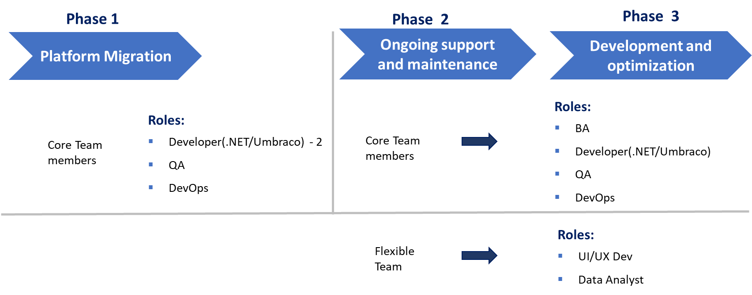

* Phase 2 and Phase 3 will have the core team members including a **Business Analyst** to co-ordinate and perform the team handling activities
* In phase 3, There will be a need for **UI/UX Developer** and **Data Analyst** depending on the optimization activities planned

# Phase 1-Estimation

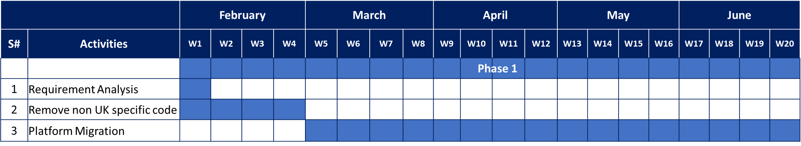

**NOTE:**

After the removal of Non-UK specific codes, we will be having the Platform Migration Phase 1. It is estimated for 4 months. Phase 2 and Phase 3 will be an ongoing process

# Pricing and Estimation

|  |  |
| --- | --- |
| **Phase** | **Pricing in USD** |
| Phase -1 |  |
| Phase -2 and 3 |  |

**Note:**

*Phase 1 is estimated for a period of 5 months*

*Phase 2 and 3 can be extended as per the requirements.*

# Relevant Experience and Case Studies

